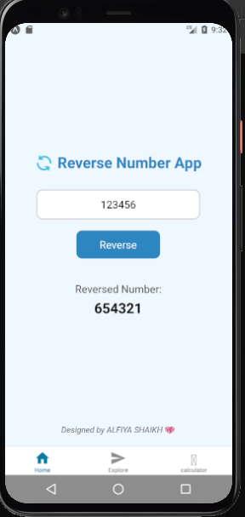

import React, { useState } from 'react';
import {
StyleSheet,
Text,
TextInput,
TouchableOpacity,
View,
} from 'react-native';

export default function App() {
const [number, setNumber] = useState('');
const [reversed, setReversed] = useState('');

// Function to reverse a number (handles negatives too)
const reverseNumber = () => {
if (!number) {
setReversed('');
return;
}

const num = parseFloat(number);
if (isNaN(num)) {
setReversed('❌ Invalid input');
return;
}

const isNegative = num < 0;
const reversedStr = Math.abs(num).toString().split('').reverse().join('');
const result = isNegative ? '-' + reversedStr : reversedStr;

setReversed(result);
};

return (
<View style={styles.container}>
<Text style={styles.title}>🔄 Reverse Number App</Text>

<TextInput
style={styles.input}
placeholder="Enter a number"
keyboardType="numeric"
value={number}
onChangeText={setNumber}
/>

<TouchableOpacity style={styles.button} onPress={reverseNumber}>
<Text style={styles.buttonText}>Reverse</Text>
</TouchableOpacity>

<View style={styles.resultBox}>
<Text style={styles.resultLabel}>Reversed Number:</Text>
<Text style={styles.result}>{reversed}</Text>
</View>

{/* Footer */}
<Text style={styles.footer}>Designed by ALFIYA SHAIKH 💖</Text>
</View>
);
}

const styles = StyleSheet.create({
container: {
flex: 1,
justifyContent: 'center',
alignItems: 'center',
padding: 20,
backgroundColor: '#f0f8ff',
},
title: {
fontSize: 26,
fontWeight: 'bold',
marginBottom: 30,
color: '#2e86c1',
},
input: {
borderWidth: 1,
borderColor: '#aaa',
borderRadius: 10,
width: '80%',
padding: 12,
fontSize: 18,
marginBottom: 20,
backgroundColor: '#fff',
textAlign: 'center',
},
button: {
backgroundColor: '#2e86c1',
paddingVertical: 12,
paddingHorizontal: 40,
borderRadius: 10,
marginBottom: 20,
},
buttonText: {
color: '#fff',
fontSize: 18,
fontWeight: '600',
},
resultBox: {
marginTop: 20,
alignItems: 'center',
},
resultLabel: {
fontSize: 18,
color: '#555',
},
result: {
fontSize: 24,
fontWeight: 'bold',
marginTop: 5,
color: '#111',
},
footer: {
position: 'absolute',
bottom: 20,
fontSize: 14,
fontStyle: 'italic',
color: '#666',
},
});

ODD OR NOT
import React, { useState } from 'react';
import {
StyleSheet,
Text,
TextInput,
TouchableOpacity,
View,
} from 'react-native';

export default function App() {
const [number, setNumber] = useState('');
const [result, setResult] = useState('');

// Function to check Odd/Even and Prime
const checkNumber = () => {
if (!number) {
setResult('');
return;
}

const num = parseInt(number);

if (isNaN(num)) {
setResult('❌ Invalid input');
return;
}

// Odd or Even
const oddEven = num % 2 === 0 ? 'Even' : 'Odd';

// Prime check
let isPrime = true;
if (num < 2) {
isPrime = false;
} else {
for (let i = 2; i <= Math.sqrt(num); i++) {
if (num % i === 0) {
isPrime = false;
break;
}
}
}

const primeStatus = isPrime ? 'Prime' : 'Not Prime';

setResult(`✅ ${num} is ${oddEven} and ${primeStatus}`);
};

return (
<View style={styles.container}>
<Text style={styles.title}>🔢 Odd/Even & Prime Checker</Text>

<TextInput
style={styles.input}
placeholder="Enter a number"
keyboardType="numeric"
value={number}
onChangeText={setNumber}
/>

<TouchableOpacity style={styles.button} onPress={checkNumber}>
<Text style={styles.buttonText}>Check</Text>
</TouchableOpacity>

<View style={styles.resultBox}>
<Text style={styles.result}>{result}</Text>
</View>

{/* Footer */}
<Text style={styles.footer}>Designed by ALFIYA SHAIKH 💖</Text>
</View>
);
}

const styles = StyleSheet.create({
container: {
flex: 1,
justifyContent: 'center',
alignItems: 'center',
padding: 20,
backgroundColor: '#f0f8ff',
},
title: {
fontSize: 26,
fontWeight: 'bold',
marginBottom: 30,
color: '#2e86c1',
},
input: {
borderWidth: 1,
borderColor: '#aaa',
borderRadius: 10,
width: '80%',
padding: 12,
fontSize: 18,
marginBottom: 20,
backgroundColor: '#fff',
textAlign: 'center',
},
button: {
backgroundColor: '#2e86c1',
paddingVertical: 12,
paddingHorizontal: 40,
borderRadius: 10,
marginBottom: 20,
},
buttonText: {
color: '#fff',
fontSize: 18,
fontWeight: '600',
},
resultBox: {
marginTop: 20,
alignItems: 'center',
},
result: {
fontSize: 20,
fontWeight: 'bold',
marginTop: 10,
color: '#111',
textAlign: 'center',
},
footer: {
position: 'absolute',
bottom: 20,
fontSize: 14,
fontStyle: 'italic',
color: '#666',
},
});

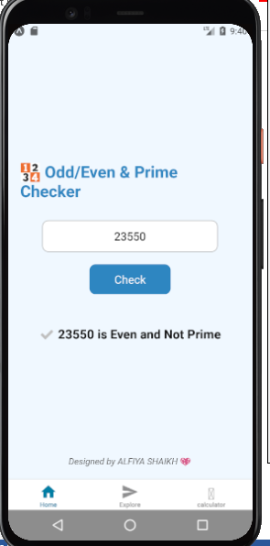

import React, { useState } from 'react';
import { StyleSheet, Text, TextInput, TouchableOpacity, View } from 'react-native';

export default function App() {
const [number, setNumber] = useState('');
const [reversed, setReversed] = useState('');

// Function to reverse a number
const reverseNumber = () => {
if (!number) {
setReversed('');
return;
}

const num = parseFloat(number);
if (isNaN(num)) {
setReversed('❌ Invalid input');
return;
}

const isNegative = num < 0;
const reversedStr = Math.abs(num).toString().split('').reverse().join('');
const result = isNegative ? '-' + reversedStr : reversedStr;

setReversed(result);
};

return (
<View style={styles.container}>
<Text style={styles.title}>🔄 Reverse Number App</Text>

<TextInput
style={styles.input}
placeholder="Enter a number"
keyboardType="numeric"
value={number}
onChangeText={setNumber}
/>

<TouchableOpacity style={styles.button} onPress={reverseNumber}>
<Text style={styles.buttonText}>Reverse</Text>
</TouchableOpacity>

<View style={styles.resultBox}>
<Text style={styles.resultLabel}>Reversed Number:</Text>
<Text style={styles.result}>{reversed}</Text>
</View>

<Text style={styles.footer}>Designed by ALFIYA SHAIKH 💖</Text>
</View>
);
}

const styles = StyleSheet.create({
container: {
flex: 1,
backgroundColor: '#f0f8ff',
justifyContent: 'center',
alignItems: 'center',
padding: 20,
},
title: {
fontSize: 26,
fontWeight: 'bold',
marginBottom: 30,
color: '#e778b0ff',
},
input: {
borderWidth: 1,
borderColor: '#c5bdbdff',
borderRadius: 10,
width: '80%',
padding: 12,
fontSize: 18,
marginBottom: 20,
backgroundColor: '#fff',
textAlign: 'center',
},
button: {
backgroundColor: '#e483b0ff',
paddingVertical: 12,
paddingHorizontal: 40,
borderRadius: 10,
marginBottom: 20,
},
buttonText: {
color: '#fff',
fontSize: 18,
fontWeight: '600',
},
resultBox: {
marginTop: 20,
alignItems: 'center',
},
resultLabel: {
fontSize: 18,
color: '#555',
},
result: {
fontSize: 24,
fontWeight: 'bold',
marginTop: 5,
color: '#111',
},
footer: {
position: 'absolute',
bottom: 20,
fontSize: 14,
fontStyle: 'italic',
color: '#666',
},
});

